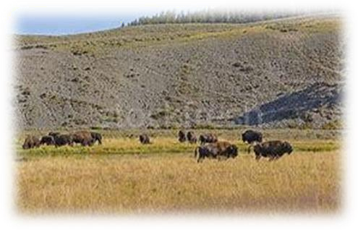
If Wishes Were Horses
Choreographer: Mark Hood
Count: 32
Wall: 4
Level: Improver
Music: “If Wishes Were Horses” by Kimber Clayton

CROSS, BACK, SIDE SHUFFLE, CROSS, BACK, SIDE SHUFFLE ¼ TURN LEFT
1-2 Step right over left, step left back
3&4 Step right to right, step left beside right, step right to right
5-6 Step left over right, step right back
7&8 Step left to left, step right beside left, step left to left with ¼ turn left

FULL TURN, SHUFFLE FORWARD, SIDE, TOGETHER, SIDE SHUFFLE ¼ TURN LEFT
1-2 Step right forward turning a ½, step left back turning a ½ Options on 1-2: walk forward on right, then left
3&4 Step forward right, step left beside right, step forward right
5-6 Step left to the left, step right beside left
7&8 Step left to the left, step right beside left, step left to left with ¼ turn left

CROSS ROCK, RECOVER, SHUFFLE ¾ TURN, WALK, WALK, SHUFFLE FORWARD
1-2 Cross rock right over left, recover onto left
- Step right to the right with ¼ turn right
& Step left beside right with ¼ turn right
- Step right in place with ¼ turn right
5-6 Step forward left, step forward right
7&8 Step forward left, step right next to left, step left forward

CROSS ROCK, RECOVER, SAILOR STEP, CROSS ROCK, RECOVER, SAILOR STEP
1-2 Cross rock right over left, recover onto left
3&4 Step right behind left, step left to the left, step right in place
5-6 Cross rock left over right, recover onto right
7&8 Step left behind right, step right to the right, step left in place

Repeat

www.country-stafke.be

